**Instruction**

**1.Reject the image if there are not exactly 3 bounding boxes.**

**2.Pop-ups are allowable if they do not significant block any of the 3 bounding boxes.**

**3.Sometimes one of the bounding boxes is inside of another, look out for them, they are usually good samples.**

**4.Images, titles, prices should be canonical. However, please be lenient. Approve if they can be seen as one canonical among several.**

**Underlying principle: Approve if they can be used as a training example in ML to recognize price, title, and image in a webpage.**

**Bad samples**

1. This one is bad because a rendering issue of Bestbuy.com. Where the product image is supposed to be is now a glitch.

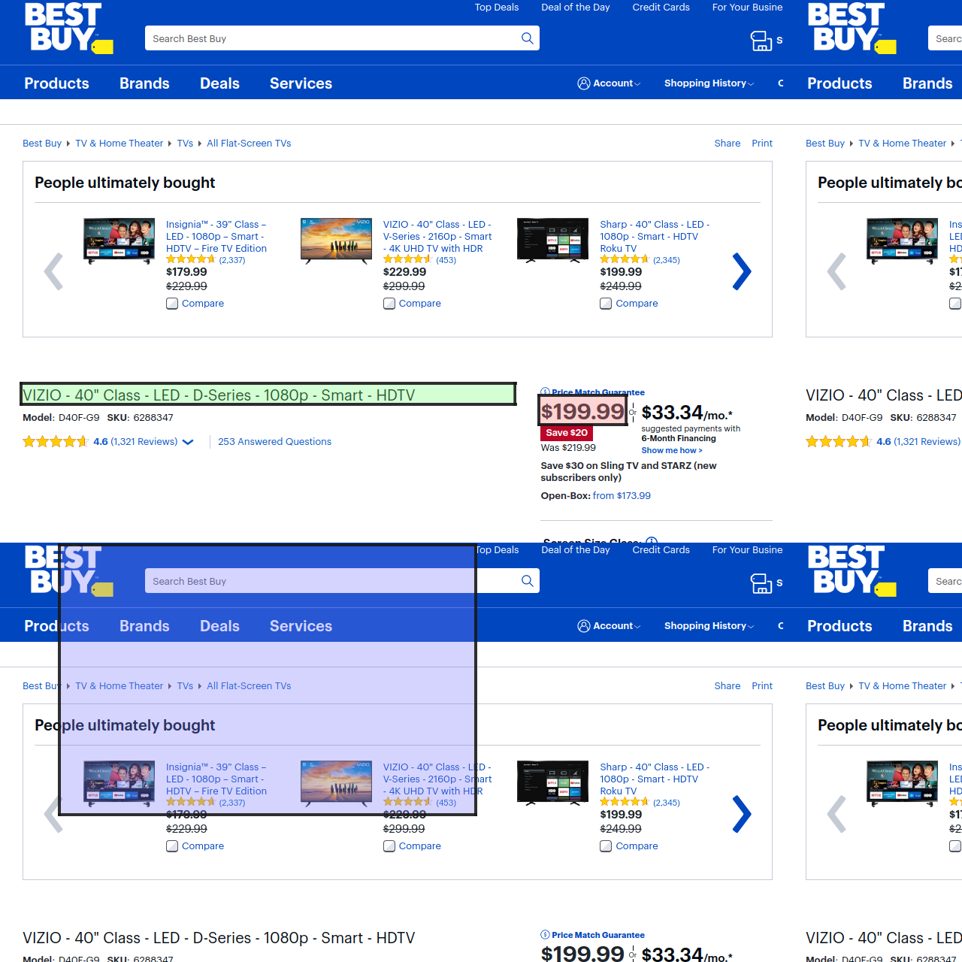

1. This is bad because the bounding box of title is totally out of place.

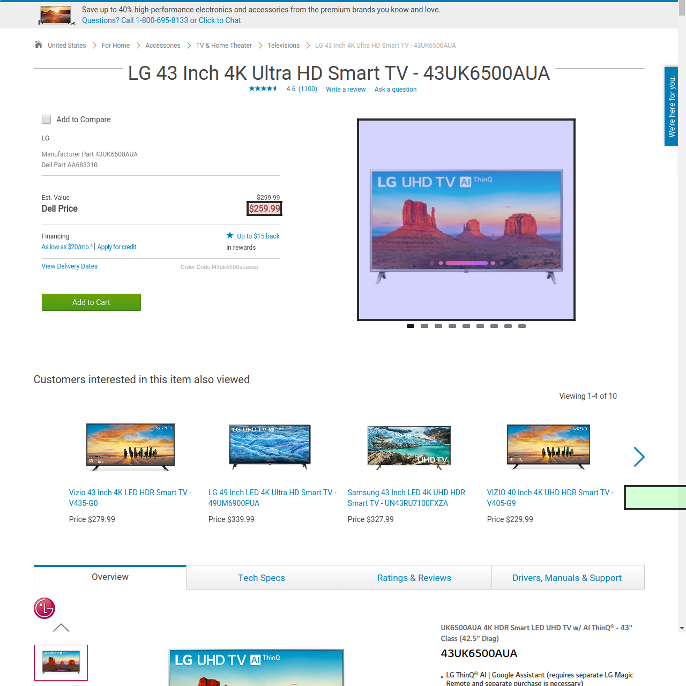

1. All three bounding boxes are not where they are supposed to be.

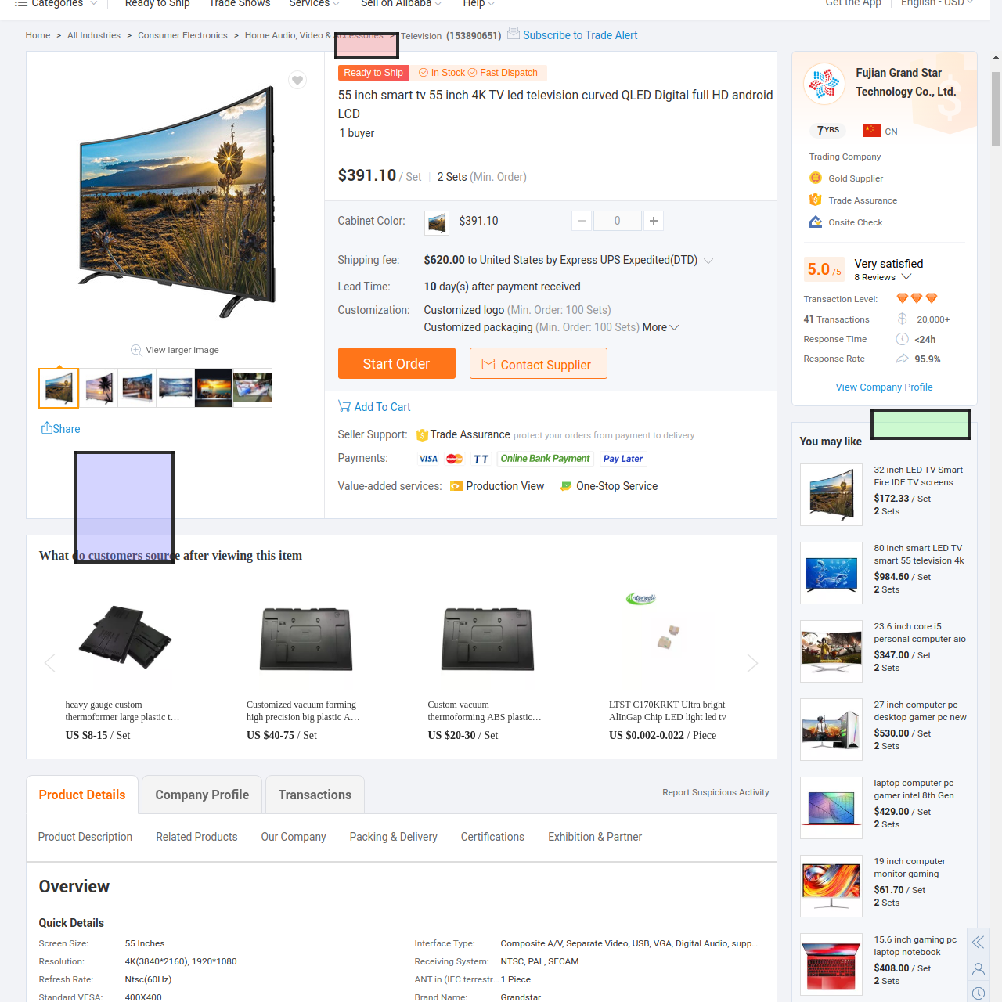

1. The pop-up blocks the bounding box of title.

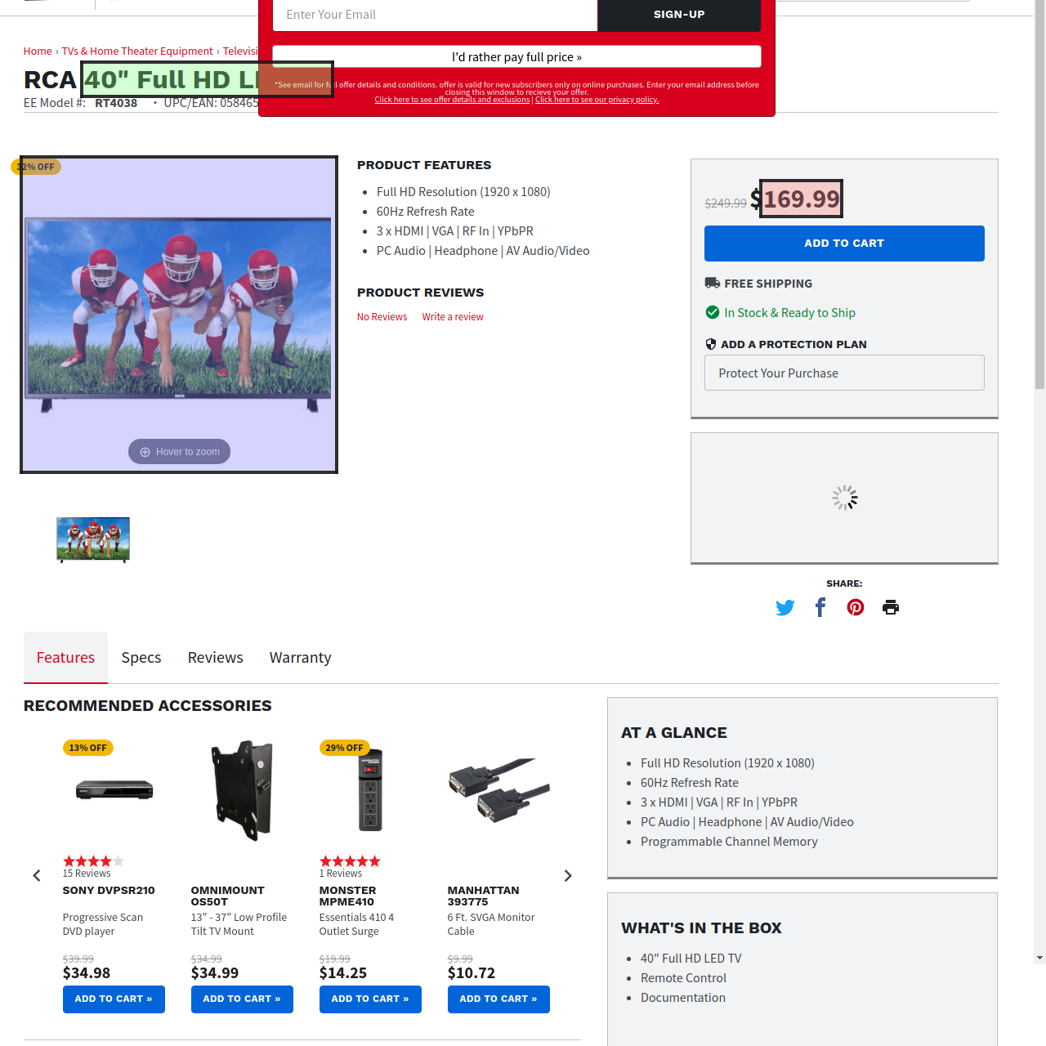

1. The title bounding box contains the title of a different product.

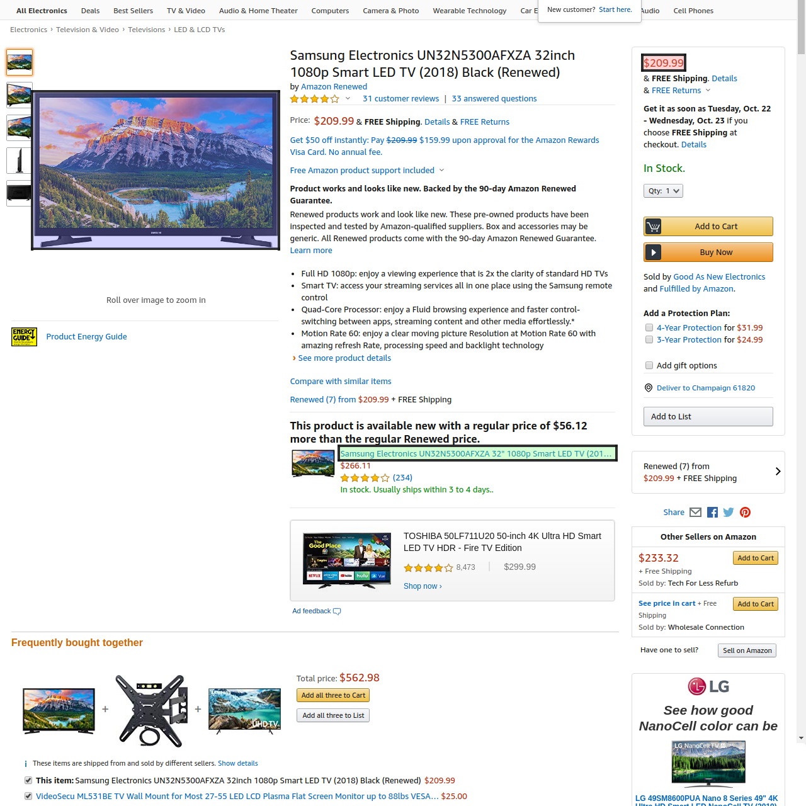

1. No bounding box of title to be found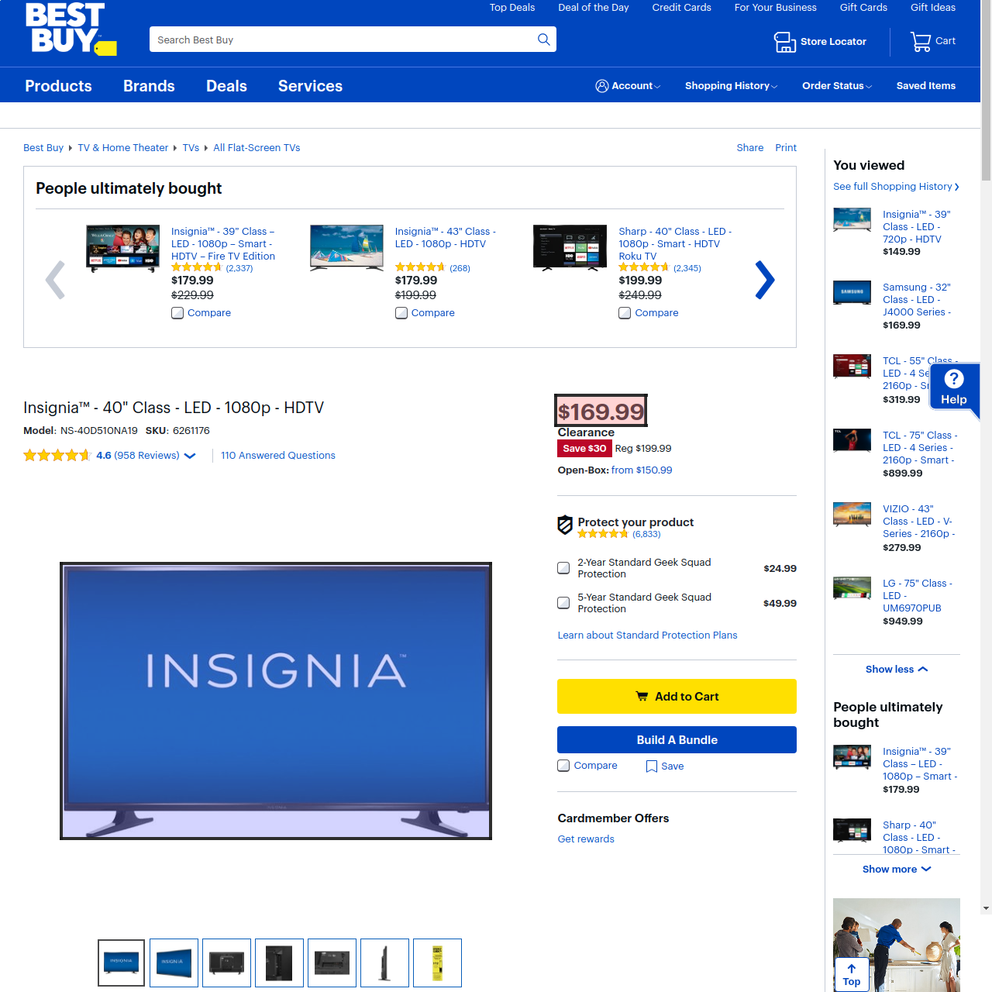
2. Although the text in the bounding box of title is similar to the title, it cannot be seen as a canonical title.

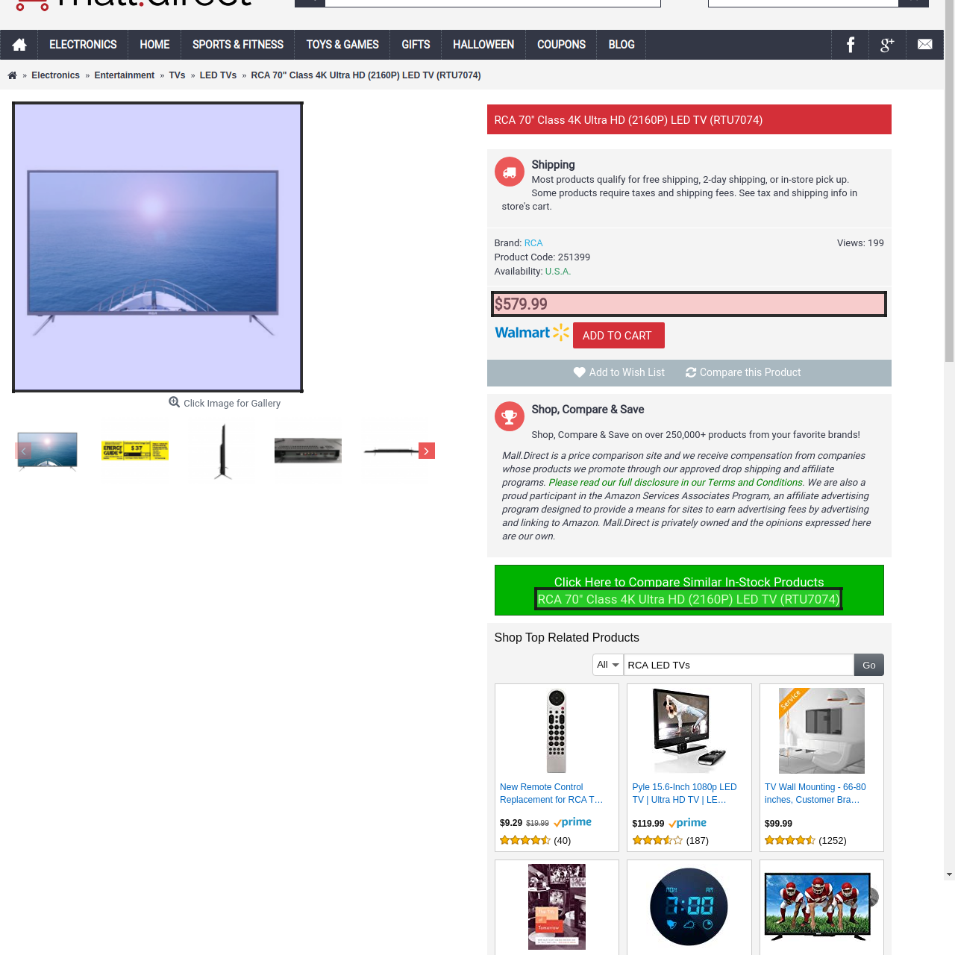 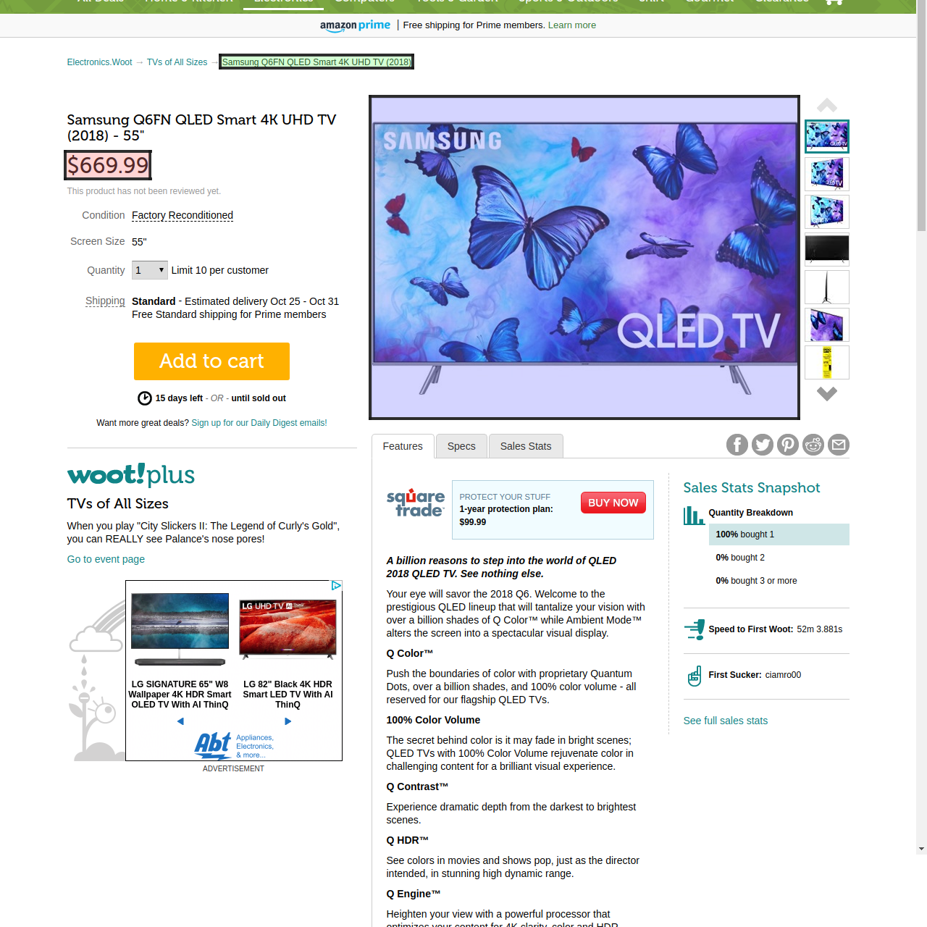

**Good samples**

1. Everything’s good

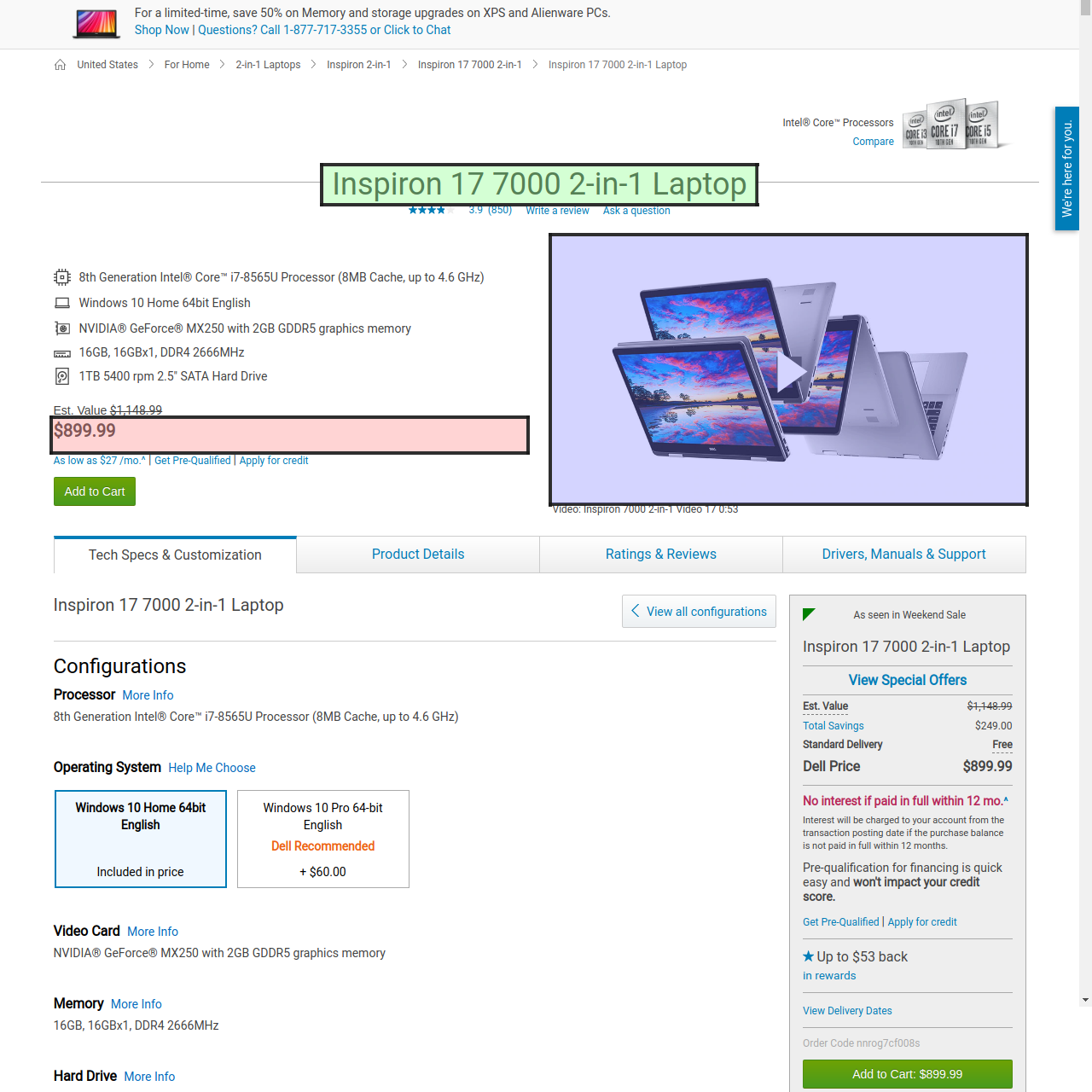

1. Although we have more than 1 prices in the webpage the one in the bounding box can be seen as canonical

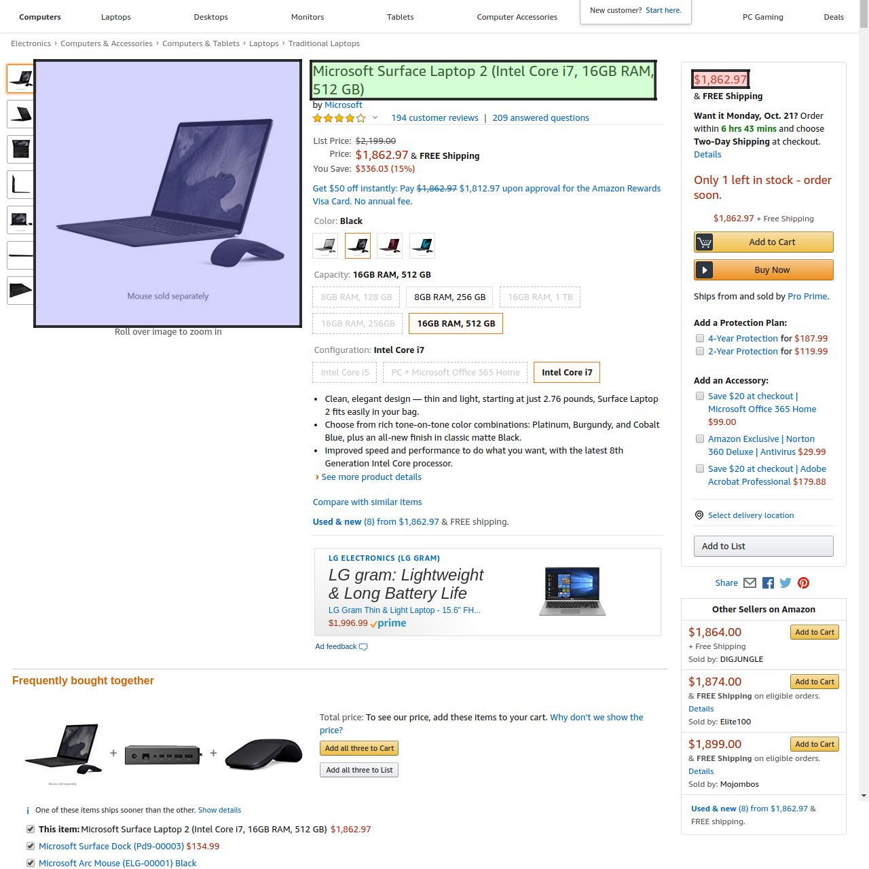

1. Although the price is not entirely bounded, it is still good.

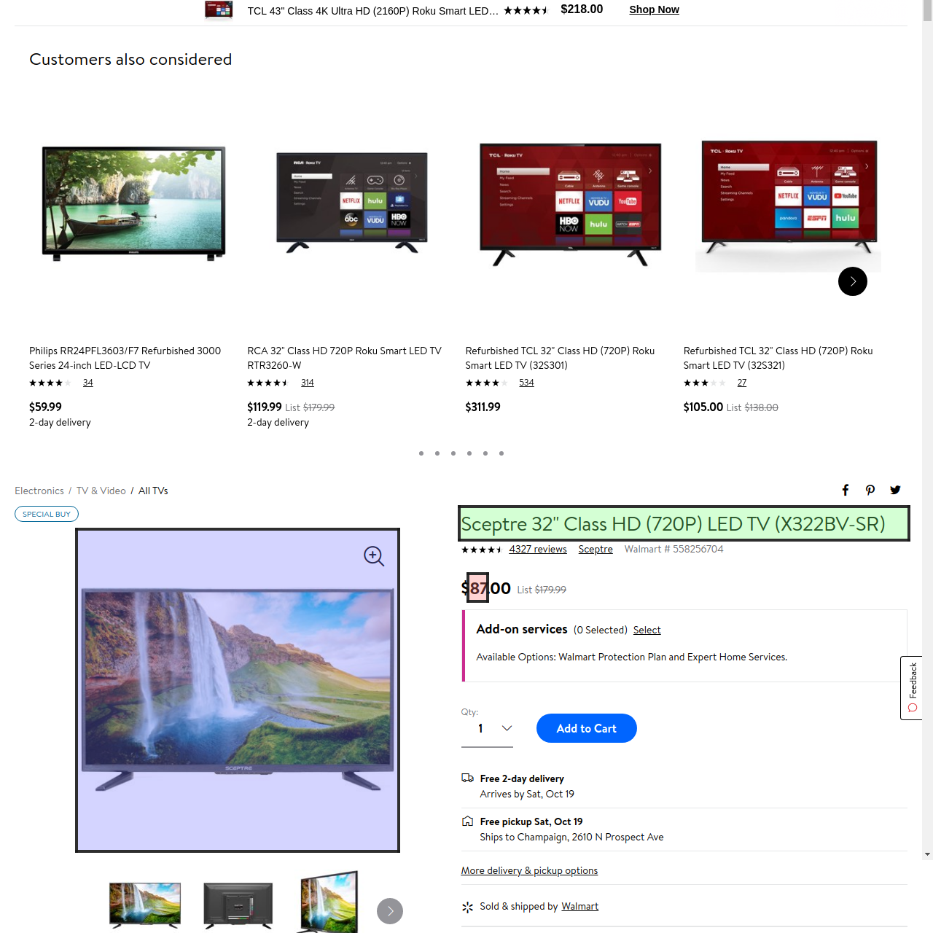

1. Look closely you will find the bounding box of the price inside of that of the title, this sample is good.

